/

**SpiraTeam®**

**Help Desk Integration Guide**

Inflectra Corporation

Contents

Introduction 1

1. KronoDesk 2

2. Zendesk 7

# Introduction

SpiraTeam® is an integrated **Application Lifecycle Management** (ALM) system that manages your project's requirements, releases, test cases, issues and tasks in one unified environment:

SpiraTeam® contains all of the features provided by SpiraTest® - our highly acclaimed **test management system** and SpiraPlan® - our **agile project management** solution. With integrated customizable dashboards of key project information, SpiraTeam® allows you to take control of your entire project lifecycle and synchronize the hitherto separate worlds of development, issues tracking, and testing.

Many organizations use helpdesk applications to interact with clients and customers. These tools can also provide powerful feedback about issues in your products. Therefore SpiraPlan, SpiraTest and SpiraTeam are capable of integrating with a number of help desk systems, including **KronoDesk**® (Inflectra’s fully featured helpdesk tool).

This guide outlines how to integrate and use SpiraTest, SpiraPlan and SpiraTeam in conjunction with third party helpdesk applications, to more closely integrate product development and testing with user feedback.

This guide assumes that the reader is familiar with both SpiraTeam and the appropriate tool being discussed. For information regarding how to use SpiraTeam, please refer to the *SpiraTeam User Manual*.

Each of the sections covers a different tool so we recommend using the table of contents on the left to locate the tool you’re looking to either integrate or migrate from, then read the installation and usage instructions.

# 

# 1. KronoDesk

This section outlines how to integrate KronoDesk® into SpiraTeam®. This will enable KronoDesk agents to log incidents emerging from a ticket directly from the KronoDesk interface into SpiraTeam. They will also be able to see and review any SpiraTeam incidents already linked to existing KronoDesk tickets.

The integration is built-in to KronoDesk out of the box, with no add-ons necessary.

## 1.1. Configuring SpiraTeam

In order for KronoDesk to successfully connect to SpiraTeam to create incidents, you need to first enable the security permissions for REST API access. To do this, please open up SpiraTeam and go to the Administration > System > Security Settings page:



You need to enter in the URL domain of your KronoDesk. This tells SpiraTeam that CORS REST API requests from this domain is authorized. For non-production environments, you can also just set the value to (*) to allow all requests:



We do not recommend this setting for production.

Once you have done this, you also need to get the API Key for the user that will be connecting to SpiraTeam from KronoDesk. Go to the User Profile page (if it’s your user) or the Administration > Edit Users page, if you want to connect as a different user:



You need to make sure that **Enable RSS Feeds** is set to Active = Yes, and that there is an RSS Token. This is your REST API Key. Make sure you have the following:

* User Name
* RSS Token

This is what you will use to connect from KronoDesk.

## 1.2. Configuring KronoDesk

Now, inside KronoDesk, please go to: Administration > Help Desk Settings > Spira Integration:



Enter the following information for your SpiraTeam instance:

* Spira URL
* Login
* API Key (RSS Token)

Then when you click [Test], you should see the following:



If you see an authentication error, please check the login and RSS Token / API Key and try again.

Now you need to associate the support agent in KronoDesk with the specific SpiraTeam user. To do this, each user needs to go to their User Profile in KronoDesk:



They should enter the Spira login and RSS Token and click Test:



Then click **Save Changes** to update your profile with this information.

## 1.3. Using KronoDesk with SpiraTeam

Now when you view a ticket in KronoDesk, you should see the Incidents tab for that ticket:



This means that you are connected to SpiraTeam but that there are no incidents logged against this help desk ticket.

If you click the **+ Add New Incident** button, you will see the following dialog appear:



You can now select the Project, then populate the Incident Name and the various required fields:



Note that the Description field is prepopulated by the Ticket Description and associated Notes, this is normally sufficient for SpiraTeam, but you can edit it and tailor the incident description if you need.

Once you click **+Add**, the new incident is logged in SpiraTeam and linked to the current ticket:



If you click on the incident hyperlink, you will see that the incident is available in SpiraTeam:



In addition, in the Attachments tab is a hyperlink for the developers to see the original help desk ticket:



# 2. Zendesk

This section outlines how to integrate Zendesk into SpiraTeam®. This will enable Zendesk agents to log incidents emerging from a ticket directly from the Zendesk interface into SpiraTeam®. They will also be able to see and review any SpiraTeam® incidents already linked to existing Zendesk tickets. The integration is in the form of a Zendesk app, available for free, from the Zendesk marketplace.

### Overview to Get Up and Running

* Use SpiraTeam version 5+ and Zendesk, using modern browsers
* Create a new administrator in SpiraTeam (called something like “Zendesk”)
* Make sure the Zendesk user has an api-key
* Install the SpiraTeam app from the Zendesk marketplace
* Configure the app with url, username, and api-key information
* Make sure SpiraTeam allows Zendesk to connect to it
* Get Zendesk to connect to Spirateam (perform an initial handshake)
* Make sure each relevant SpiraTeam project is set up to work with Zendesk

## 2.1. Installing the SpiraTeam app

This section outlines the steps required to ensure that the links between Zendesk and Spirateam will work correctly.

### Summary of requirements

There are a number of elements needed for both applications to successfully communicate:

* A working installation of SpiraTeam v5.0 or later
* The SpiraTeam server must have an authenticated certificate and be accessible over HTTPS
* A working account with Zendesk
* Zendesk agents must be using a modern browser (IE10 or later)
* A SpiraTeam admin account whose username and API-key (**not** password) can be saved inside the Zendesk app settings

### 2.1.1 Initial Configuration of SpiraTeam

Zendesk and SpiraTeam need to communicate and post data to one another cross domain. To ensure effective security SpiraTeam therefore needs to be accessible via HTTPS (i.e. using a certificate). If this is not already in place, contact your network administration for support.

**Note**: all SpiraTeam hosted accounts are already accessible via HTTPS (only).

Zendesk and SpiraTeam communicate through a security protocol called CORs to ensure that each application only receives data from trusted domains. The subdomain of your Zendesk account is required by SpiraTeam to validate any calls it receives.

Log in as a project-level administrator to SpiraTeam, go to the Administration home page and scroll to System > Security Settings.

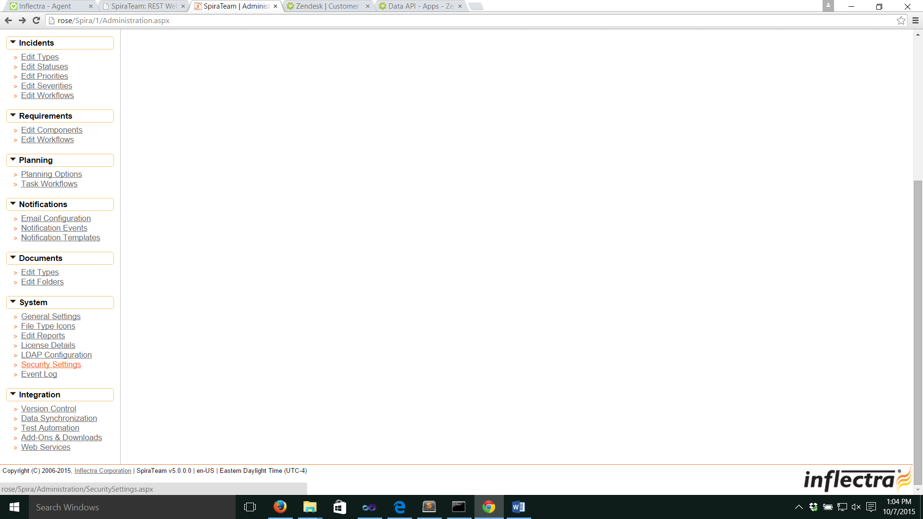

At the bottom of the Security Settings page, enter the Zendesk subdomain in the “Allowed Domains” text box, making sure to include the full url (i.e including https:// before the domain address). Click <Update> for the changes to take effect. The url should be in the format of: “**https://yoursubdomain.zendesk.com**”

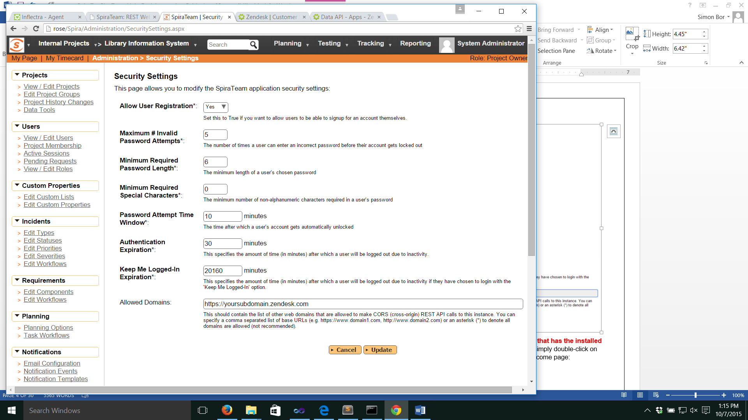

**Important:** if this field is left blank, NO domains will be allowed to interact with SpiraTeam via CORs. If an asterisk (*) is entered, ALL domains will be able to do so (not recommended).

The Zendesk app uses the details of a SpiraTeam user to authenticate with SpiraTeam. This needs to be, for the initial setup, a user with administrator privileges. We recommend creating a specific user account (such as “Zendesk”), so that the only incidents created by that account can be traced back to Zendesk.

**Note**: all tickets logged with Zendesk will be marked as originating from this user. This means that the Zendesk team do not need to have individual SpiraTeam logins.

Go to the Administration home page and scroll to Users > View / Edit Users.

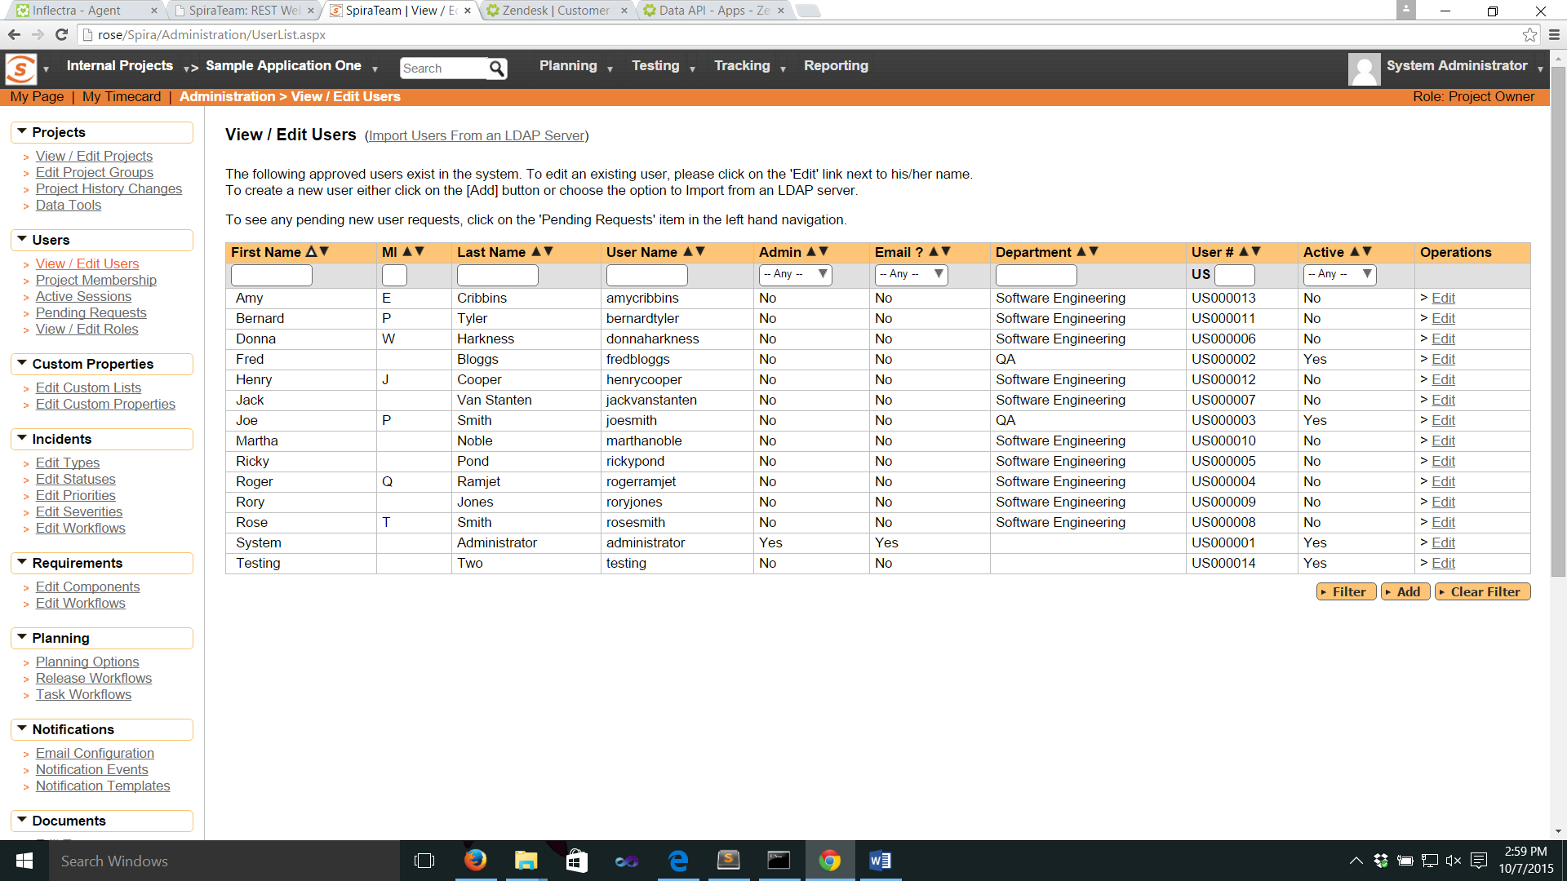

Click the <Add User> button on the bottom right of the page.

Fill in the required fields (see below), and make sure that:

* System Administrator is set to “Yes”
* Active is set to “Yes”
* Locked Out is set to “No”
* RSS Token is enabled
* That an RSS Token is displayed

Click <Insert> to add the new user.

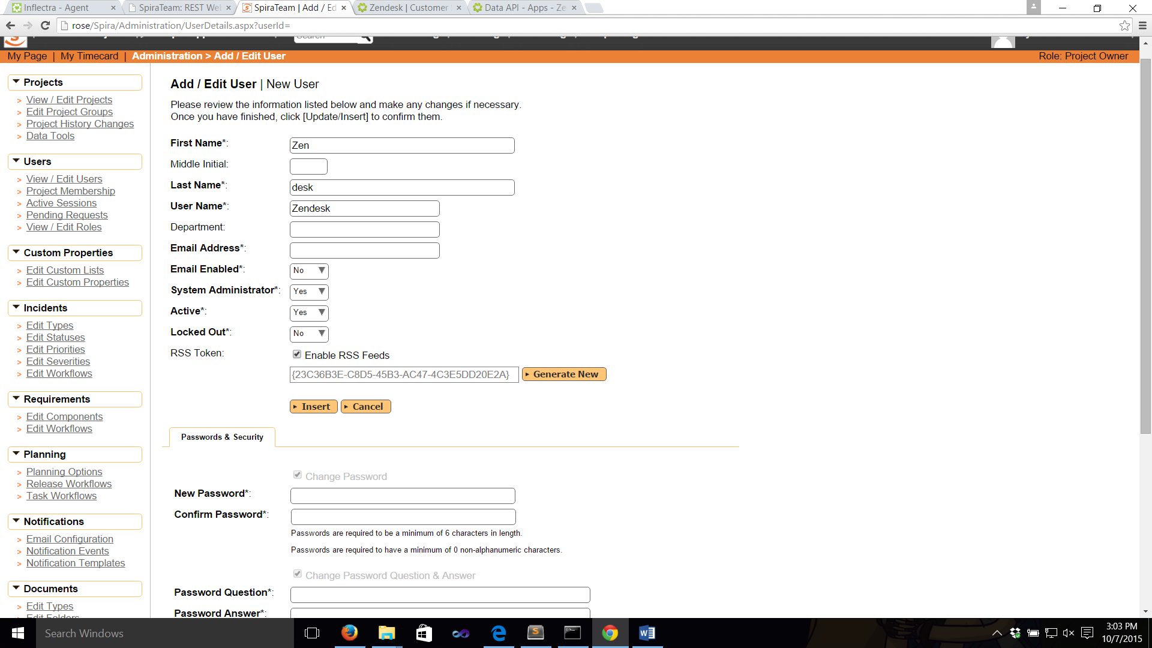

### 2.1.2 Install and Configure the SpiraTeam App in Zendesk

First, find an install the free SpiraTeam App from within Zendesk. Only administrators on Zendesk can install apps. Navigate to the Admin panel, and select Marketplace from the Apps menu. Search for “SpiraTeam” in the search field on the right, or browse by “Issues Tracking”.

You can also browse the [Zendesk app website](https://www.zendesk.com/apps).

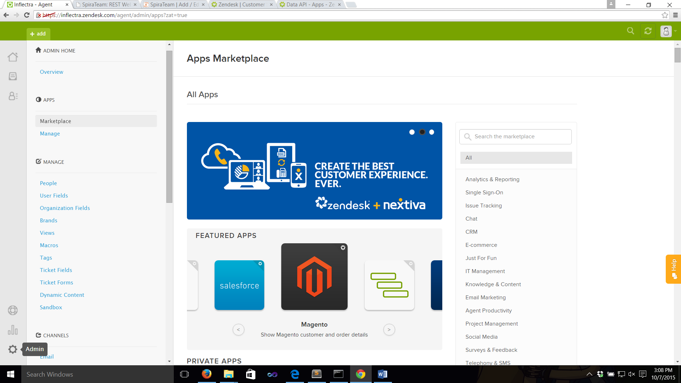

Once the application is installed, enter required information in the settings page of the app. Go to Admin > Apps > Manage in Zendesk to see the list of installed applications.

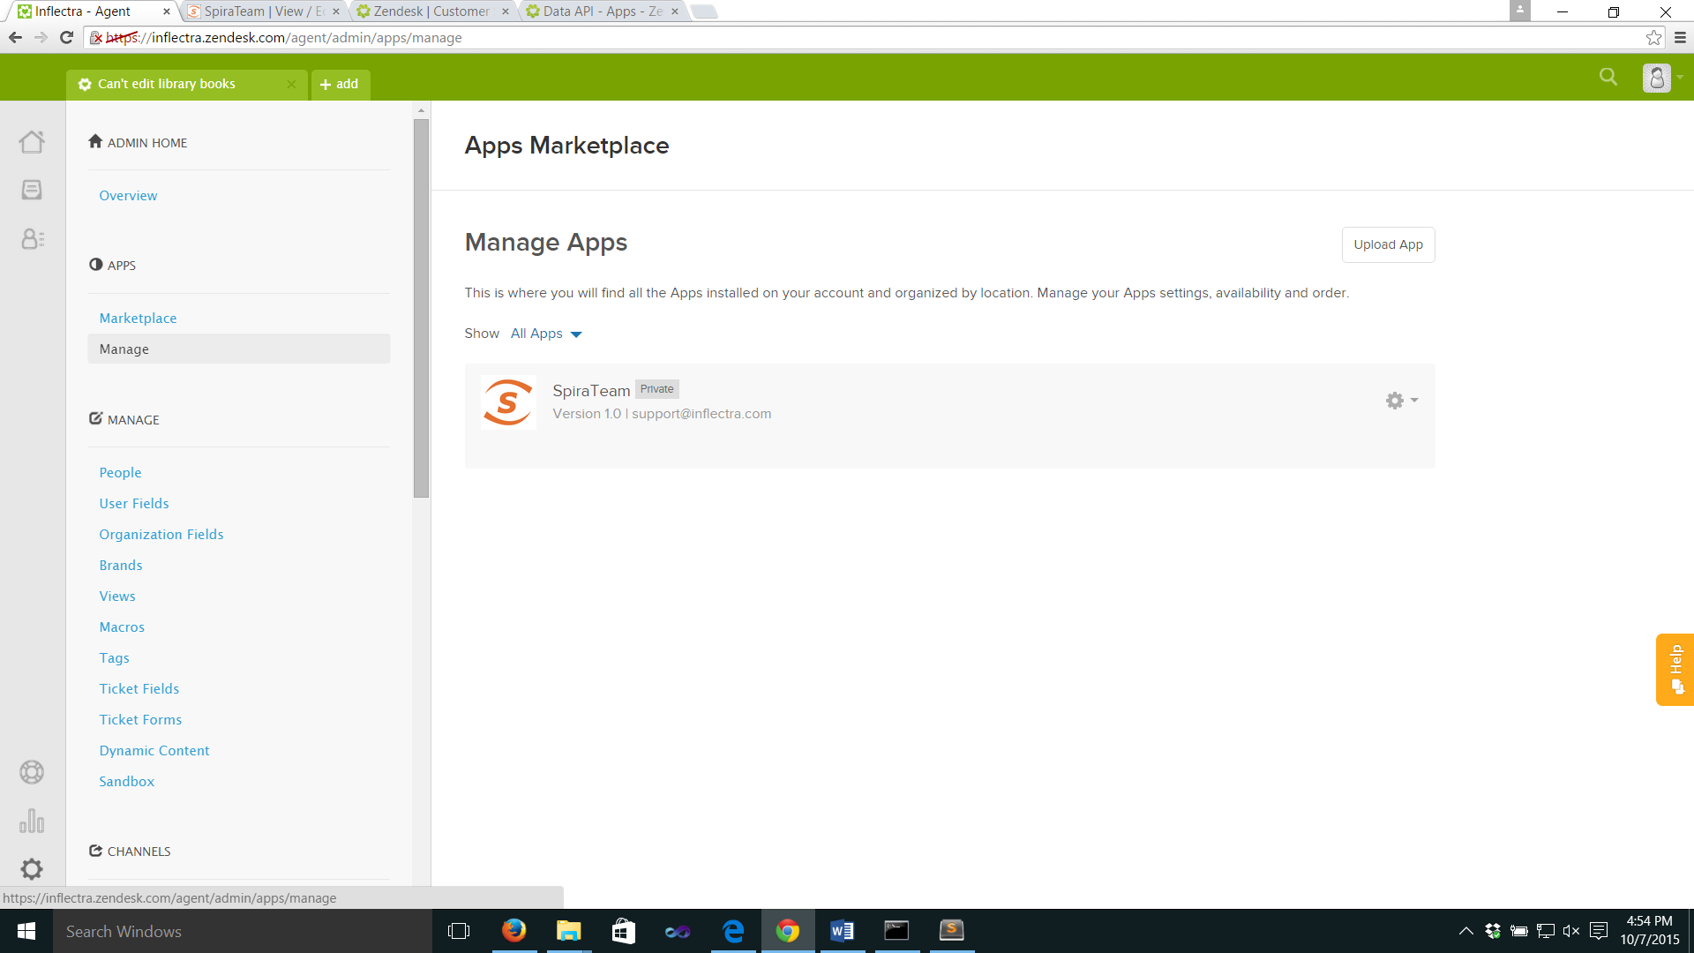

Make sure the application is enabled. Right click on the app’s gear icon to change settings

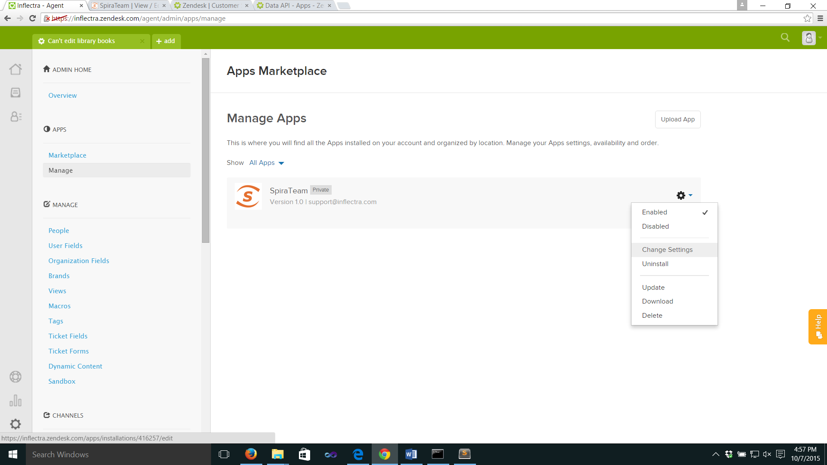

In the settings screen, make sure all input boxes are correctly filled in. Enter the username and API key that you created inside SpiraTeam above, as well as the address of SpiraTeam. Make sure that the API key is an alphanumeric string contained within curly braces – { }. Click <Update>.

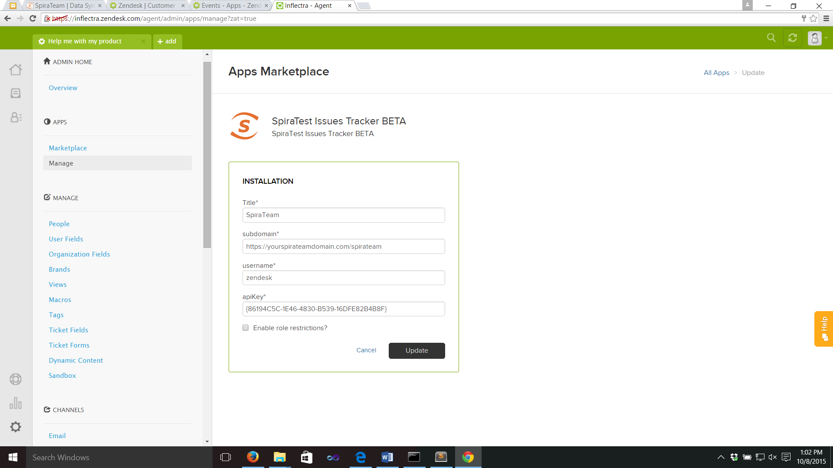

### 2.1.3 Connecting Zendesk to SpiraTeam

Zendesk should now be able to communicate fully with SpiraTeam. In order for SpiraTeam to be informed that you are using the Zendesk app, simply navigate to any ticket, click on the app sidebar (on the right of the Zendesk window) and locate the SpiraTeam app. You should see a screen like that below, giving you a welcome message on the successful connection of Zendesk to SpiraTeam.

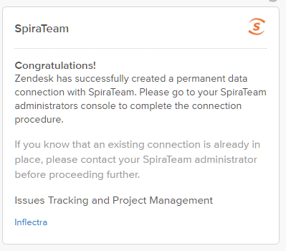

If you instead see a message like that below (note that you will also see a Zendesk service notification), please check your network settings, and double check through the steps outline above.

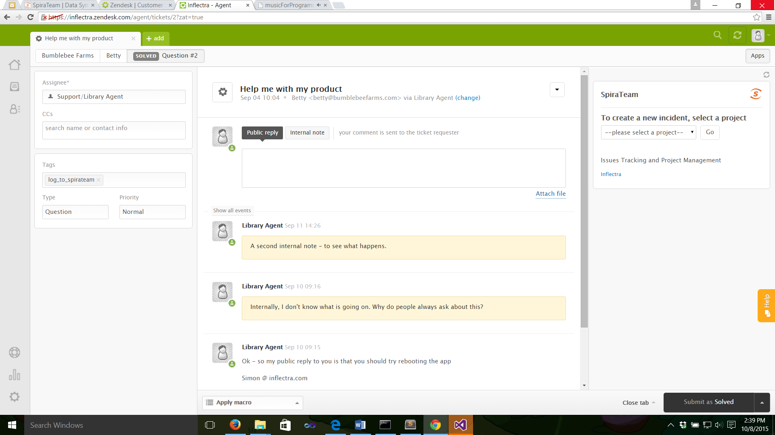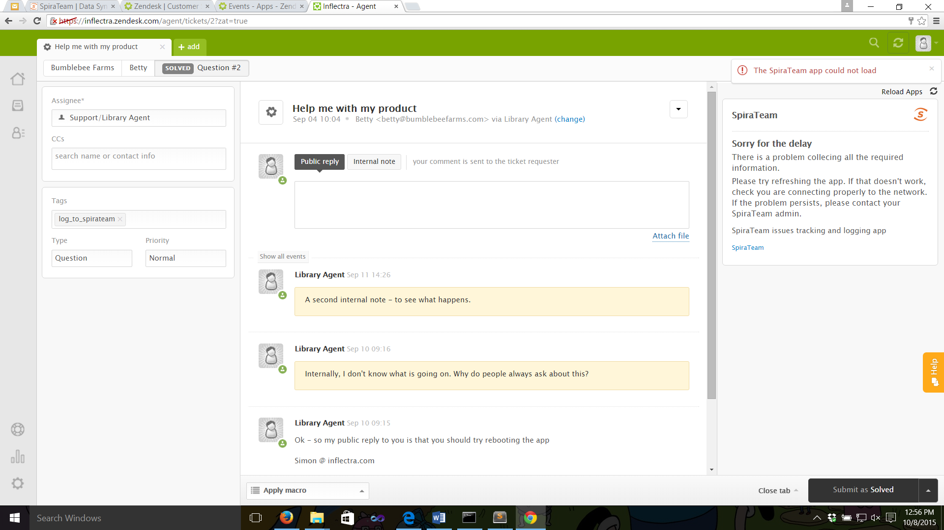

### 2.1.4 Connecting SpiraTeam to Zendesk

Zendesk can now retrieve information form SpiraTeam. For Zendesk to be able to write all the information it needs to SpiraTeam, you need to grant Zendesk access in each relevant project (i.e. any project that a Zendesk agent may need to submit an incident about).

If you wish, at this time you can change the account of the dedicated “Zendesk” user to no longer be an administrator. Make sure proper permissions are set so that the user has full access to incidents in all relevant projects.

In SpiraTeam, navigate to a project Zendesk will need access to. Go to the SpiraTeam administration panel and then Integration > Data Synchronization.

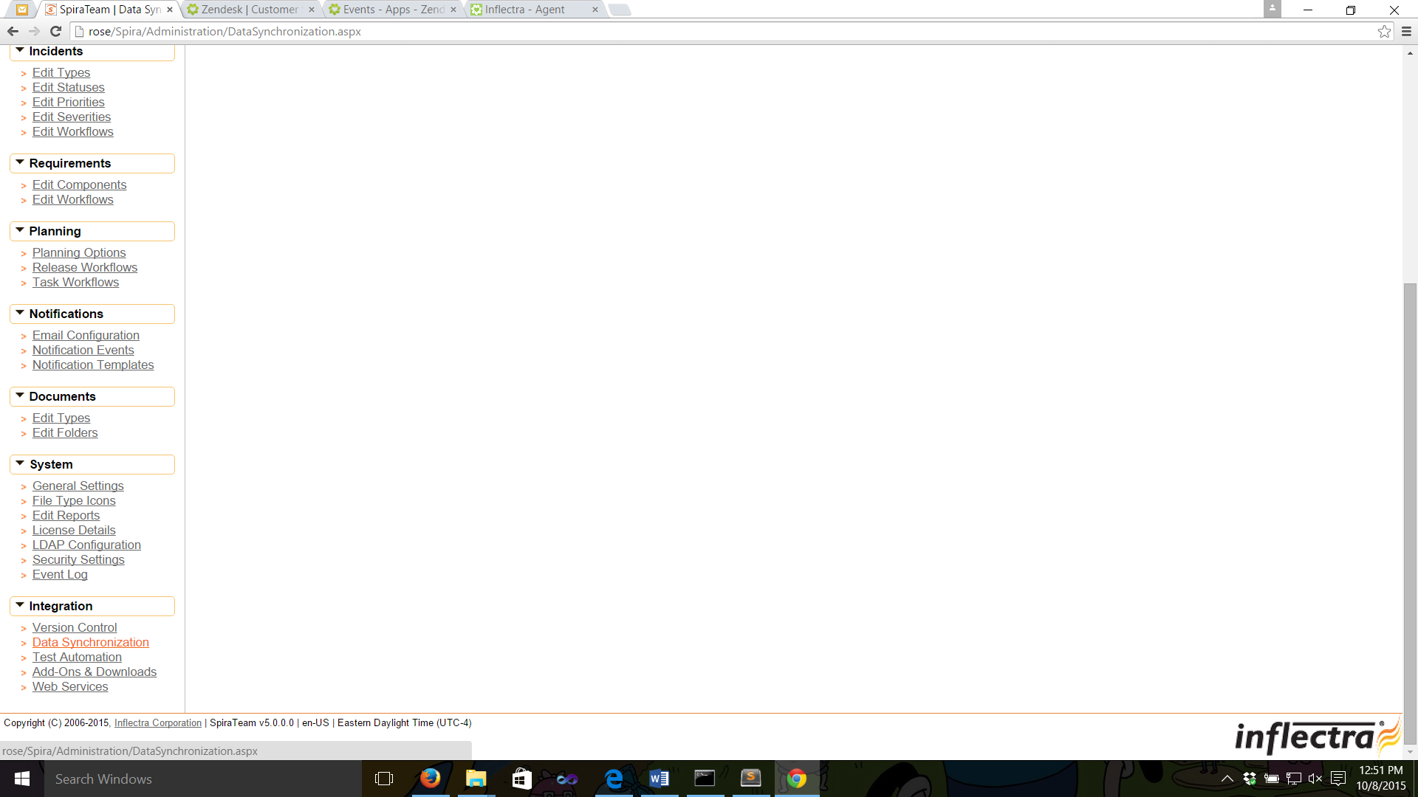

This will show you the list of current external tools that can synchronize custom data directly with SpiraTeam. Zendesk should appear as the last “Plug-In” in the table.

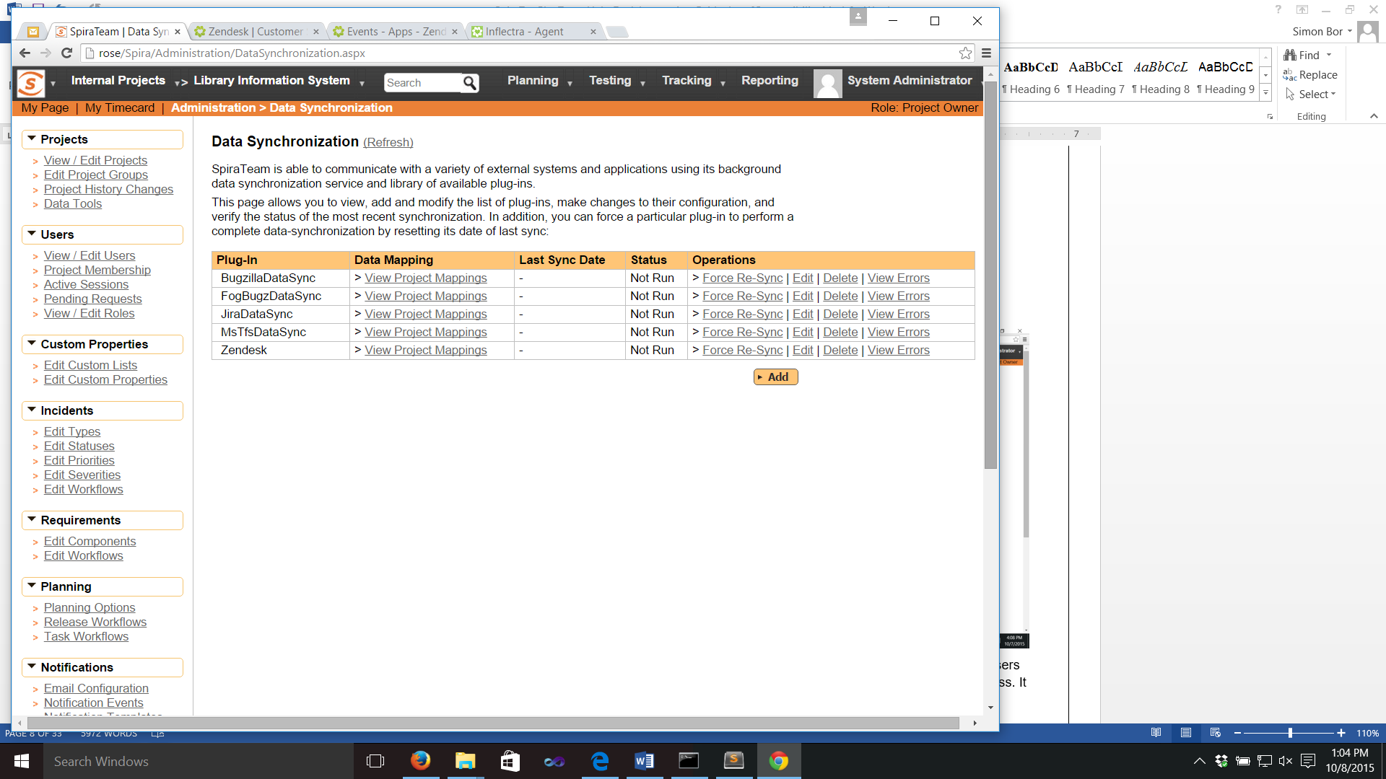

Click on <View Project Mappings>. Set Active to “Yes”. Type in any value for External Key (this is a required field but because SpiraTeam does not write to Zendesk it is never used by the app). Click <Update>.

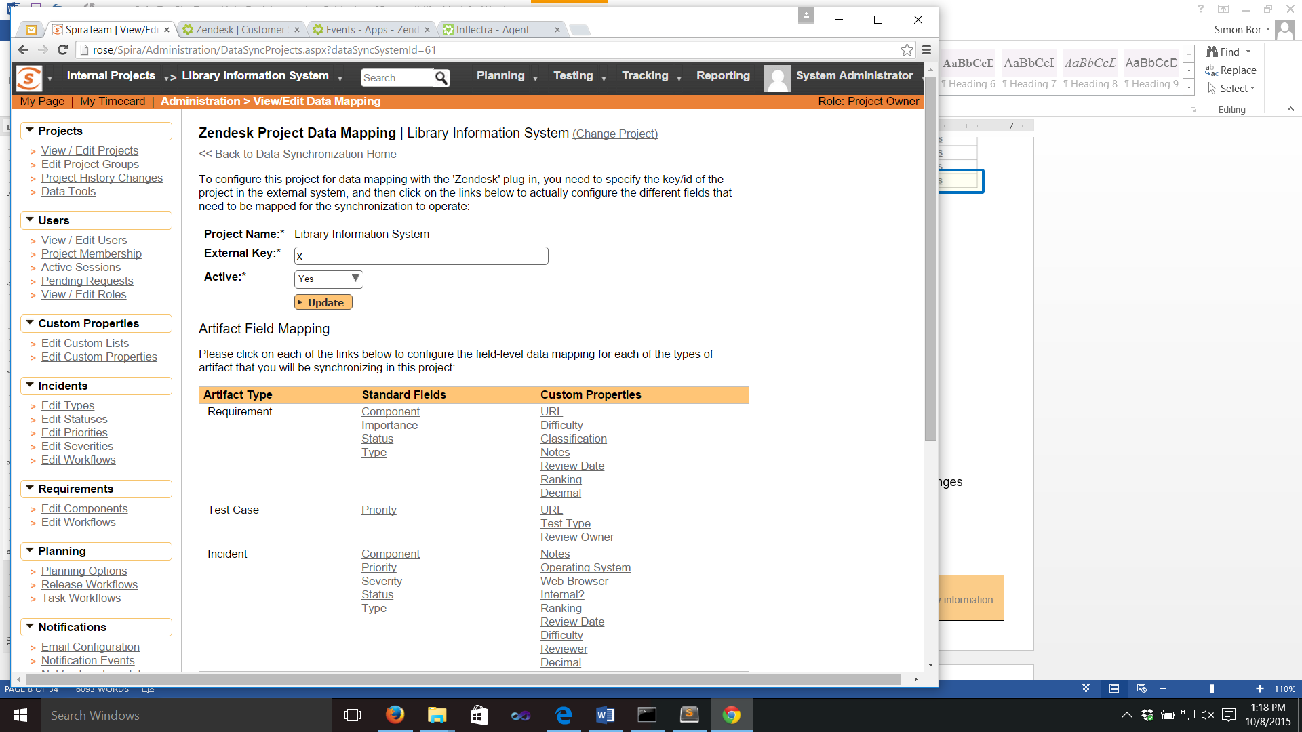

**NOTES**:

* The screen will return with a selection of configurable fields below the Update button. No changes here are required.
* There is no need to enter the <Edit> screen for the mapping. Indeed, settings here are automatically generated by the Zendesk app and should not be altered.

**Repeat the above steps for every project Zendesk will need access to.**

## 2.2. Creating an Incident in SpiraTeam

Zendesk agents are able to create an incident from within Zendesk that is logged directly into SpiraTeam. The app should not be visible to the public.

## When an agent has a ticket, which raises an issue to pass to a development team, they open the app sidebar on the right hand side of Zendesk. They will see the following screen.



In order to log an incident, the agent must decide which project the issue relates to. SpiraTeam will list all active projects in the drop down list. If an agent is unsure which project to select, we recommend that they discuss the issue with the development team first. Select a project and click <Go>.

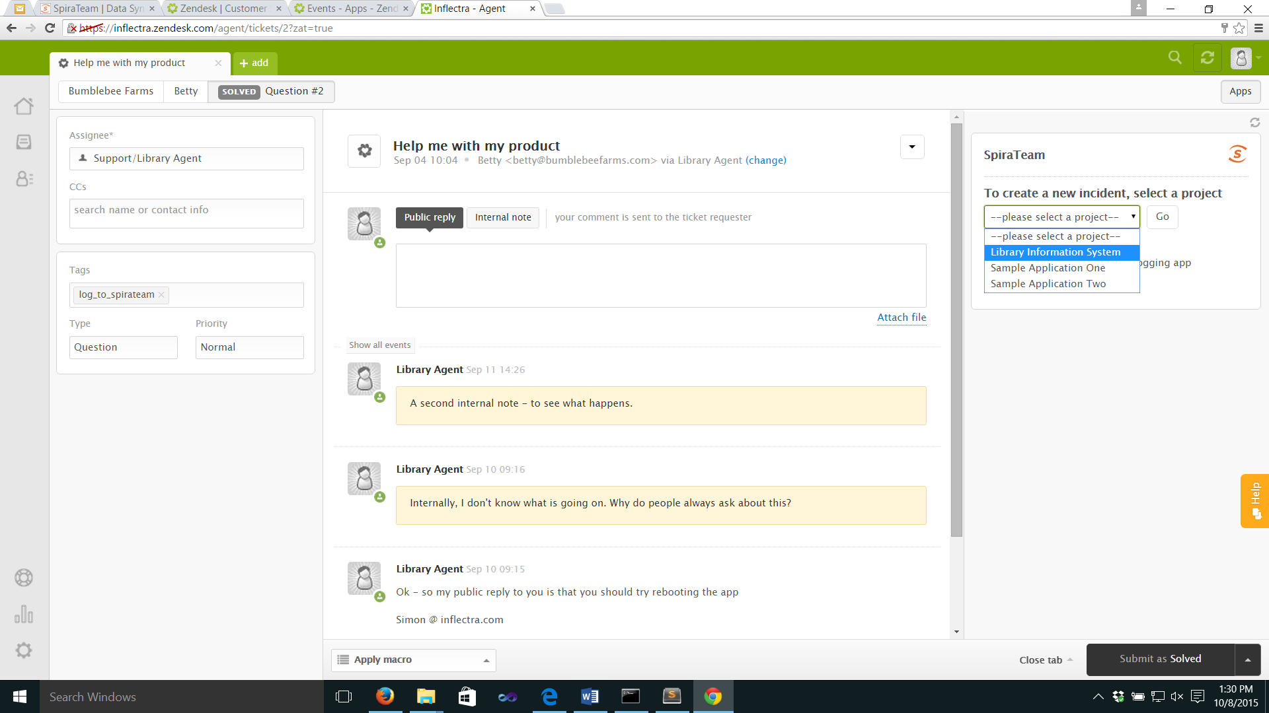

Zendesk will load fields specific to that project, including any custom properties or components. By default, as a minimum, the app collects Incident Type, Priority, Release, and Owner lists, all of which are required to be filled in, along with a subject field and a note.

By default, the subject field will be the same as the ticket’s current subject, but the agent can change this to make as clear as possible to the developer – changing the subject in the SpiraTeam app will NOT change the subject of the ticket itself.

The Notes to Developers is initially left blank, so that the agent can provide meaningful information. If the agent wants to include the comment history of the ticket after their own notes, click <Add comment history to description>. NOTE: clicking this repeatedly will paste in the comment history multiple times.

|  |  |
| --- | --- |
| *The default form, where all fields are required before submission* | *An example of a comment history added to the notes field:* |

When a project has additional fields (such as components or custom properties), these are also displayed. The app provides a split view of the fields – those that are required and those that are optional. The tab at the top of the app lets agents switch between both.

|  |  |
| --- | --- |
| *Required fields visible* | *Optional fields visible* |

If the agent wishes to cancel logging the incident, or has chosen the wrong project, click the <Back> button.

Once the form has been filled in, click <Log Incident>. If any of the fields have been left blank a notification will display and the form will not be processed. Once everything has been entered correctly, Zendesk attempts to send the form to SpiraTeam, along with links to any attachments stored with the ticket.

If Zendesk is not successful, a warning notification will be displayed (see below), and the agent is asked to attempt again.

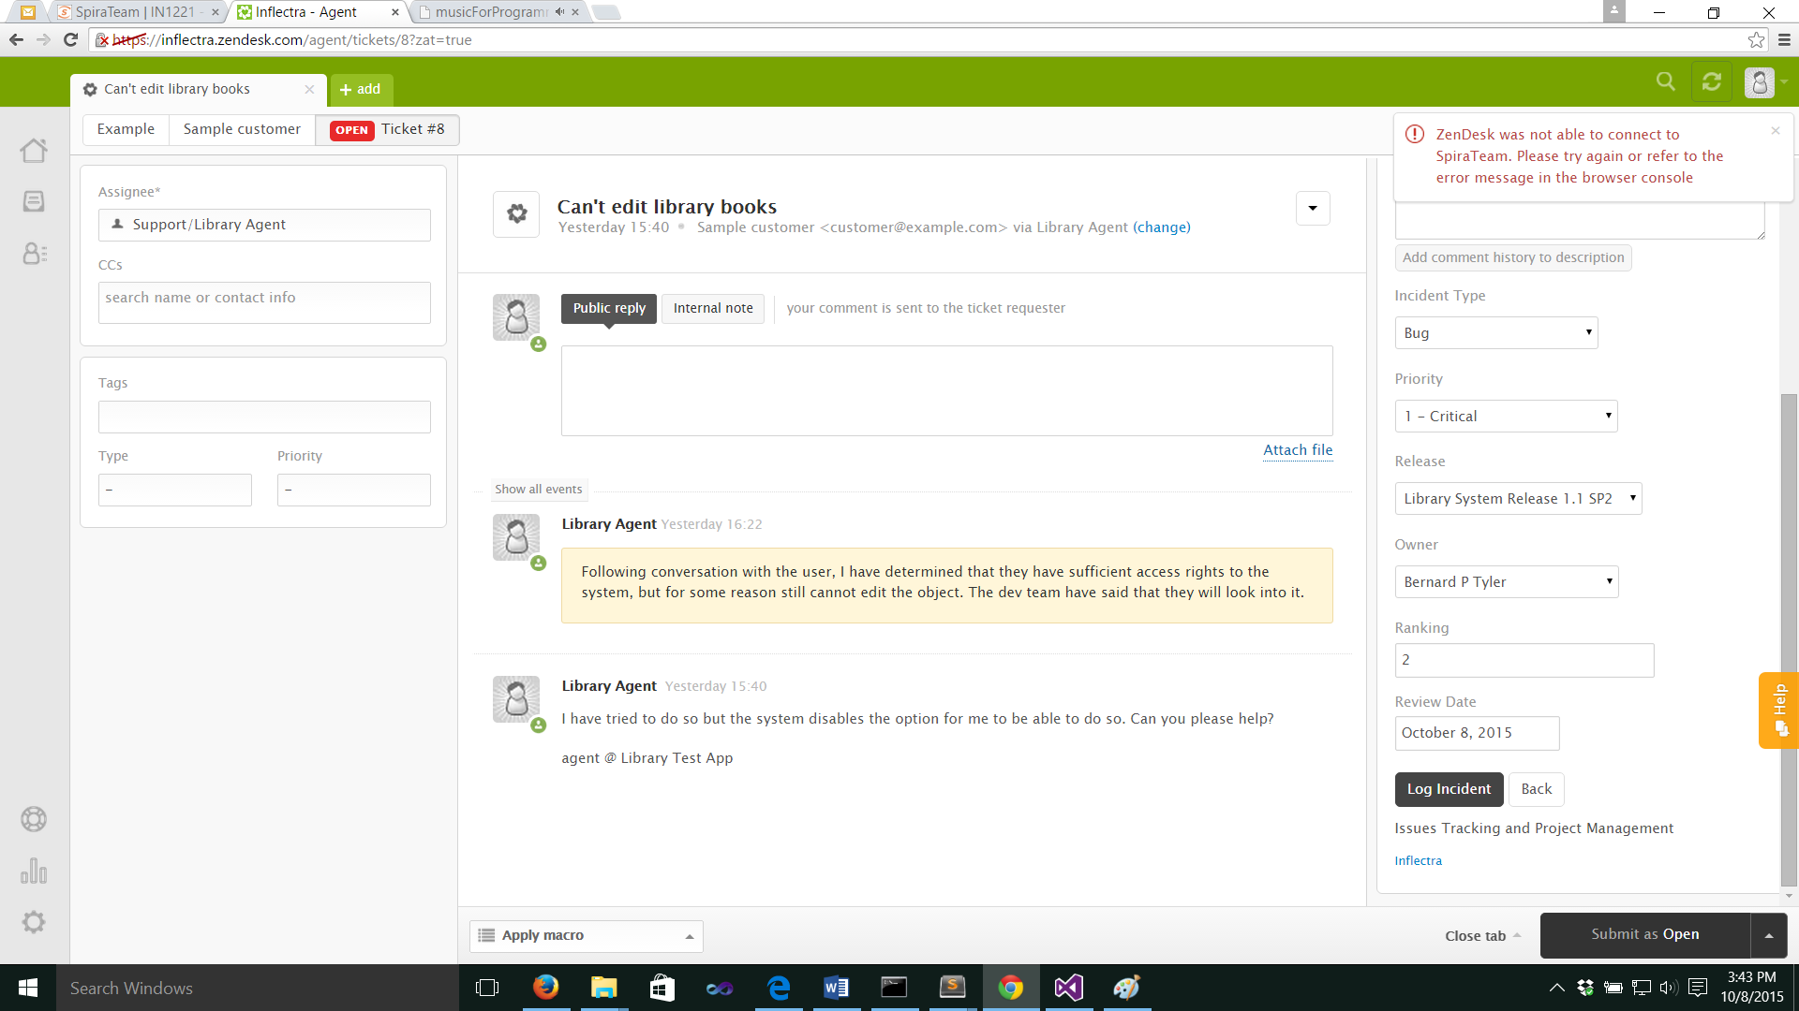

## 2.3 Reviewing the Incident in SpiraTeam

Back in SpiraTeam the new incident should be visible within the main incident log. Details about the incident can be altered as needed, without risk of breaking the connection with Zendesk.

NOTE: On the incidents screen, you should notice a new field on the Overview page, called “Zendesk ID”. This is the ID of the specific Zendesk ticket. Editing this field will break the connection and is not advised.

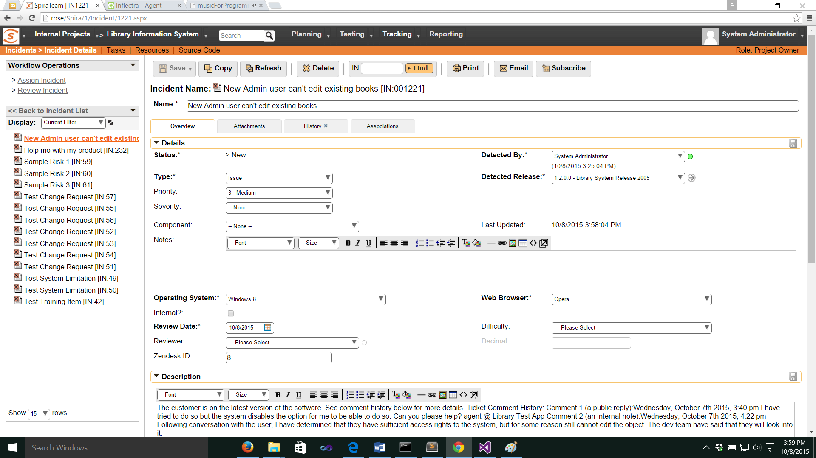

## 2.4. Reviewing SpiraTeam Incidents Linked to a Zendesk Ticket

As soon as the incident has been successfully logged to SpiraTeam, the app in Zendesk will return to the screen showing lists of projects, in case another incident needs to be logged.

In addition, information about any incidents linked to the ticket are clearly shown, including the most up to date status from SpiraTeam so that the agent can clearly see whether an issue is resolved or not.

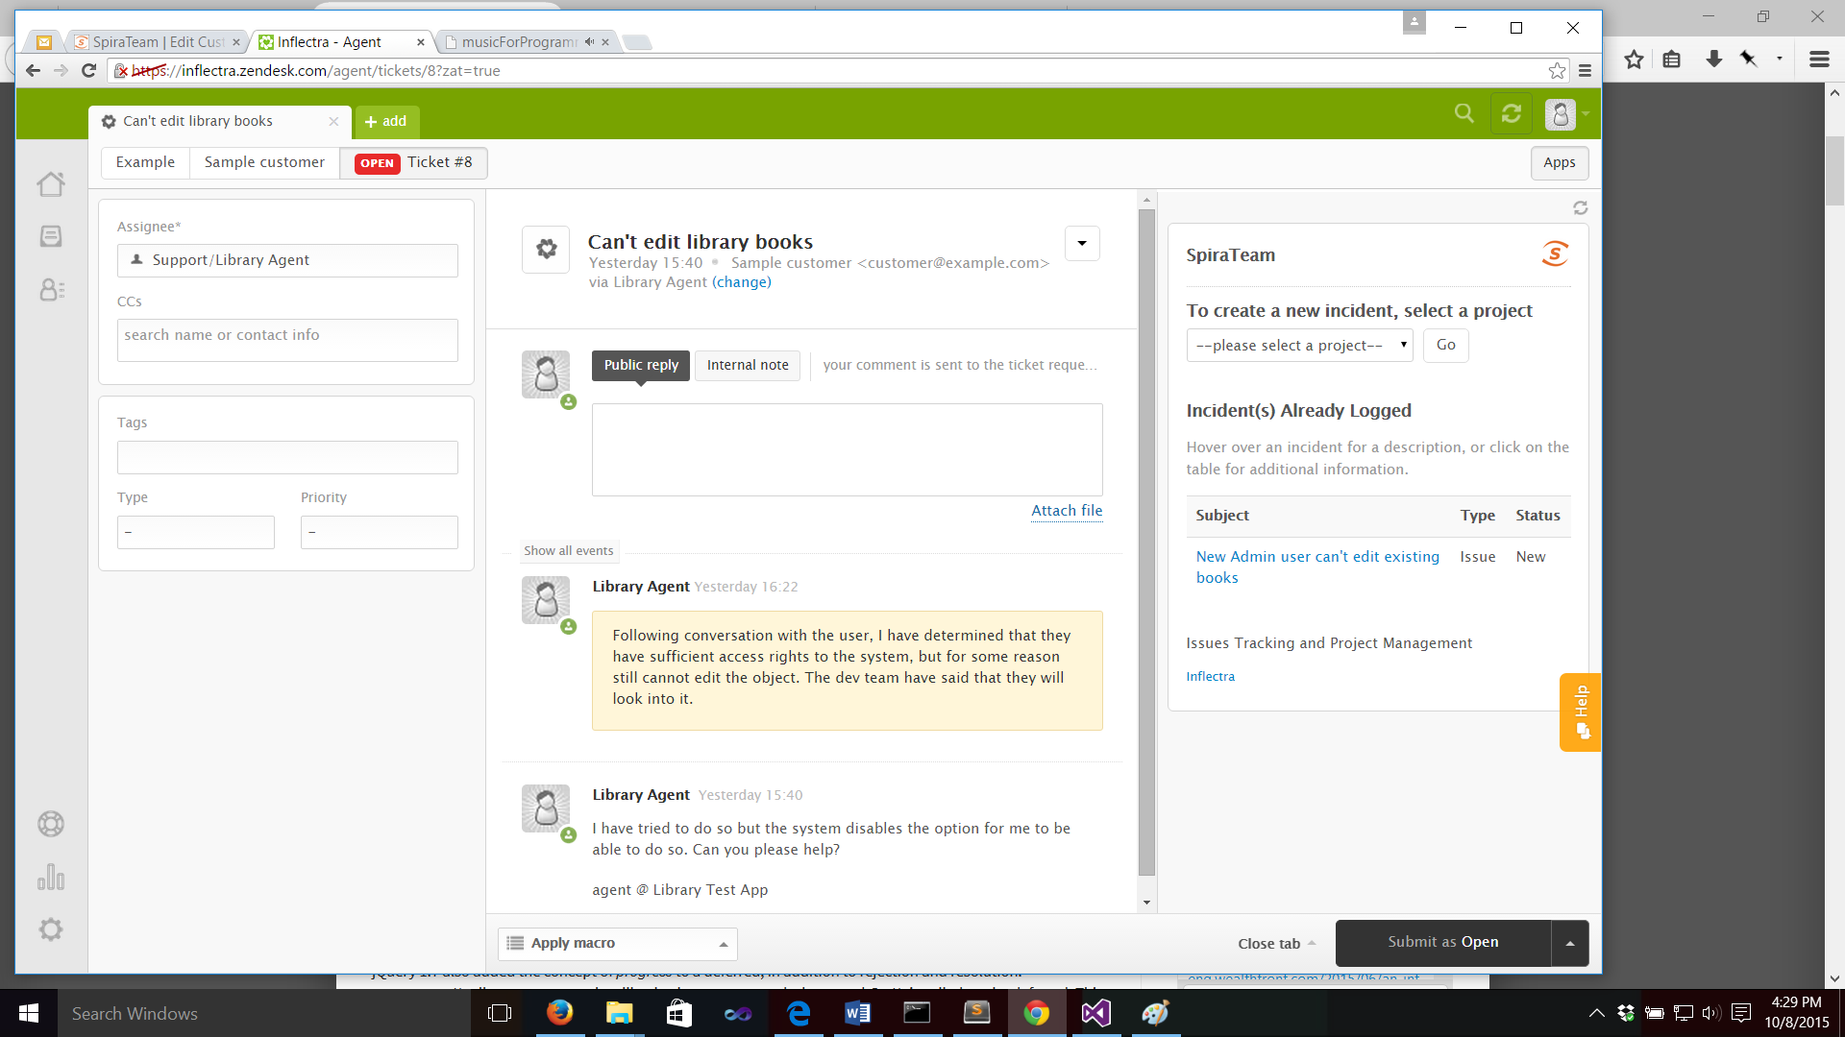

Hovering over a particular incident pops up the description to give the agent quick access to additional information.

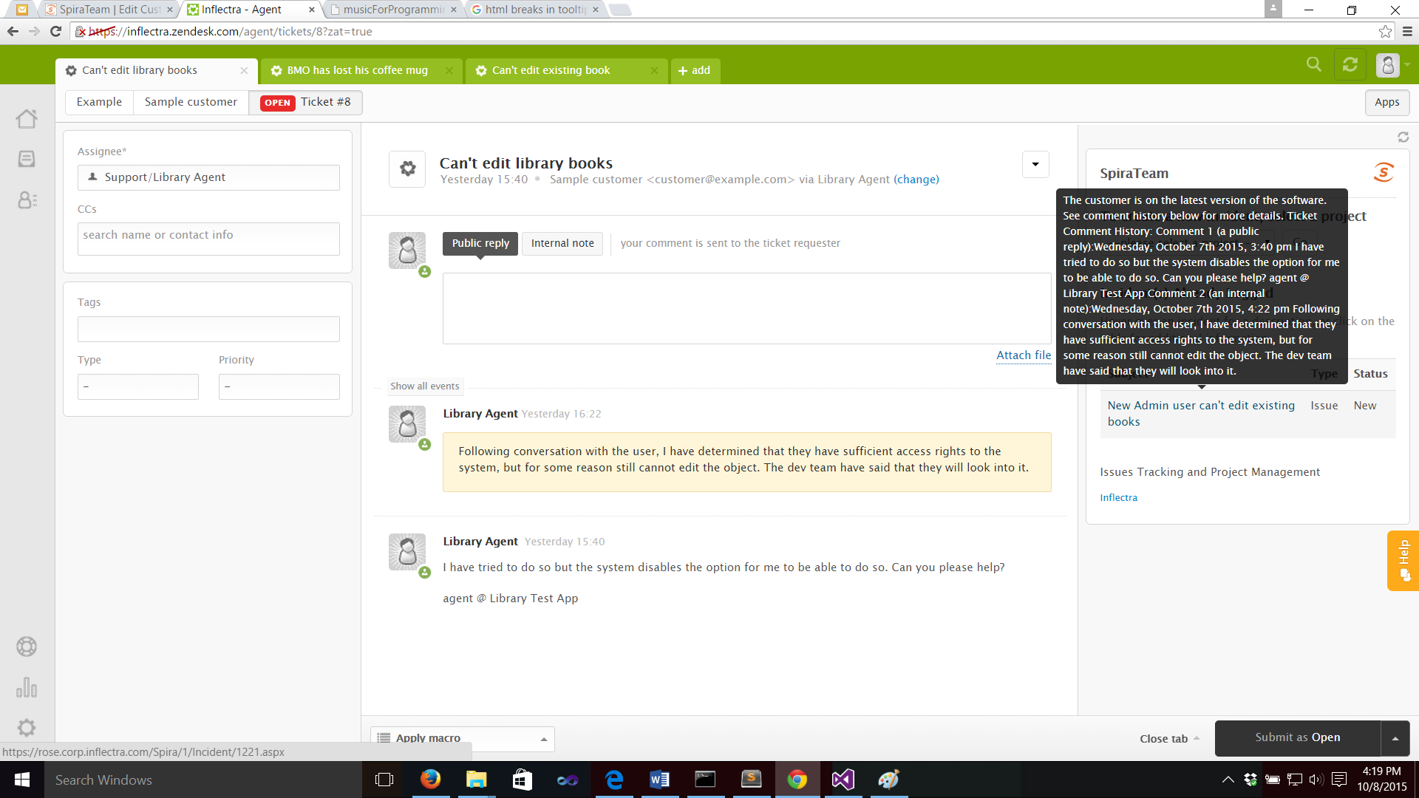

Finally, clicking on any incident will display a modal pop up table with fuller details about all linked incidents, including the incident ID to help the agent follow up as needed with the developers.

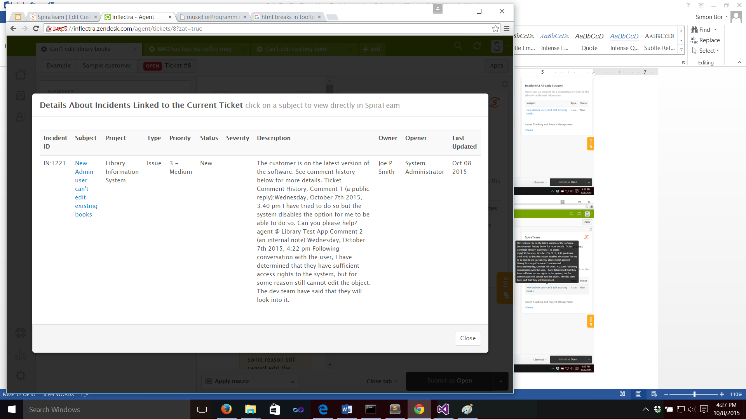

Also shown on this table is the Last Updated date of the incident. Hovering over the data will display a tooltip with the time of the update.

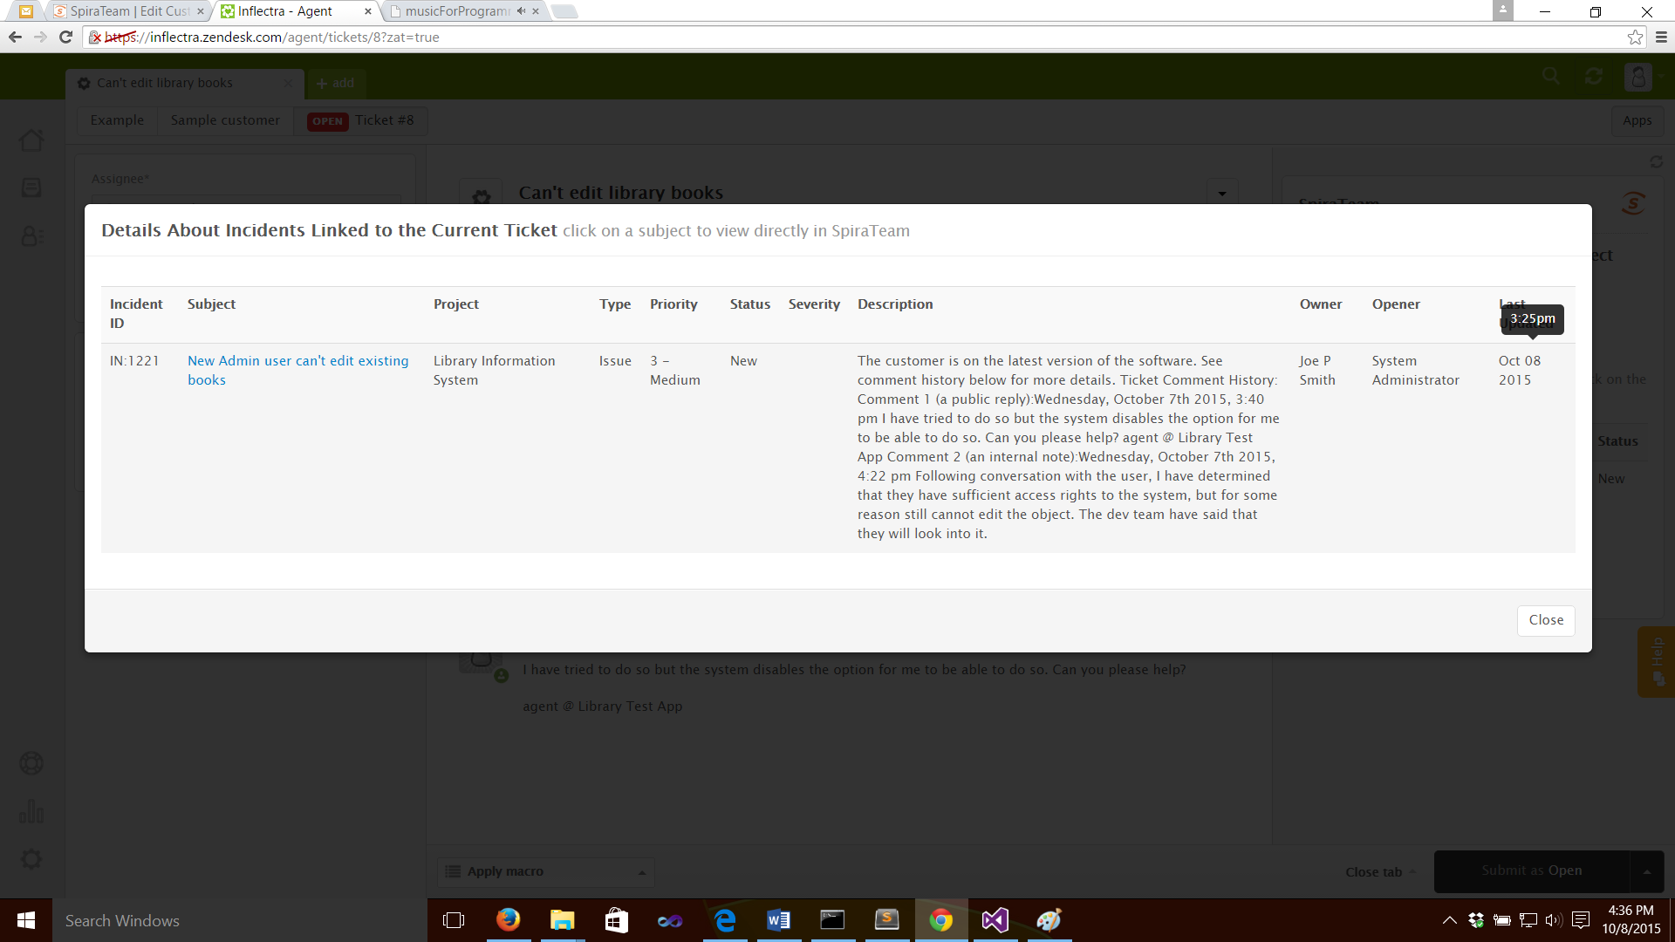

#### Legal Notices

This publication is provided as is without warranty of any kind, either express or implied, including, but not limited to, the implied warranties of merchantability, fitness for a particular purpose, or non-infringement.

This publication could include technical inaccuracies or typographical errors. Changes are periodically added to the information contained herein; these changes will be incorporated in new editions of the publication. Inflectra Corporation may make improvements and/or changes in the product(s) and/or program(s) and/or service(s) described in this publication at any time.

The sections in this guide that discuss internet web security are provided as suggestions and guidelines. Internet security is constantly evolving field, and our suggestions are no substitute for an up-to-date understanding of the vulnerabilities inherent in deploying internet or web applications, and Inflectra cannot be held liable for any losses due to breaches of security, compromise of data or other cyber-attacks that may result from following our recommendations.

SpiraTest®, SpiraPlan®, SpiraTeam® and Inflectra® are registered trademarks of Inflectra Corporation in the United States of America and other countries. Microsoft®, Windows®, Explorer® and Microsoft Project® are registered trademarks of Microsoft Corporation. All other trademarks and product names are property of their respective holders.

Please send comments and questions to:

Technical Publications

Inflectra Corporation

8121 Georgia Ave, Suite 504

Silver Spring, MD 20910-4957

U.S.A.

6H[*support@inflectra.com*](mailto:support@inflectra.com)